

Faculty of APPLIED & computer sciences

Computer science DEPARTMENT

**Diploma:** Information Technology

**Subject:** Web Management 3.1

**Assessment Type:** Assignment (Assessment 3)

**Examiner:** Mr. N. Leduma

**Moderator:** Mr. X.Piyose

**Internal Code:** AIWEX3A

**Submission date:** 26 May 2025

|  |  |  |
| --- | --- | --- |
| Student Number | Surname | Initials |
| 221649921 | Nengovhela | J |
| 223622818 | Rakobela | SG |
| 223049395 | Mpenyana | S |
| 223195979 | Chabalala | S |
| 223630519 | Chauke | P |
| 223059110 | Mudanisi | v |

**TABLE OF CONTENTS**

* Purpose of the Website
* Goal of the Website
* Website Objectives
* Intended Audience
* Problem or Opportunity Addressed
* Website Content
* Planning Analysis Sheet
* Website Goal
* Desired Results
* Page Titles
* Needed Information
* Content Sources
* Site Map
* Conclusion
* References

**1. Purpose of the Site**

This website aims to give novices a thorough introduction to the foundations of Python programming. It functions as an interactive learning tool that effectively teaches users fundamental Python concepts by fusing theoretical explanations with real-world code examples.

**2. Website Goals**

To impart the fundamentals of Python programming in an approachable and captivating way  
  
To offer interactive code samples for users to examine and play with  
  
To design a methodical educational program for complete novices  
  
To provide a user-friendly, responsive interface that is compatible with all devices

**3. Intended Audience**

Complete novices with no prior knowledge of programming  
  
High school and college/university students who want to learn python  
  
Non-technical professionals investigating the fundamentals of programming  
  
Instructors looking for extra resources for beginning Python classes

**4. Problem Addressed**

* The steep learning curve for programming beginners
* Lack of free, well-structured Python learning resources
* Difficulty finding beginner-friendly content with immediate practical examples
* Information overload for new learners with too many advanced concepts

**5. Content Included**

* Core Python concepts (variables, data types, control flow)
* Function implementation and usage
* Object-oriented programming basics
* Interactive code examples with explanations
* Visual learning aids and diagrams
* Responsive design for all device types
* Contact and about sections for user engagement

**B). Planning Analysis Sheet**

**1. Website Goal**

Create a clean, single‐page “Learn Python Basics” website that guides absolute beginners step by step through Python fundamentals using concise explanations, illustrative images, and downloadable examples.

**2. Describe the goal of your web site in one or two sentences.**

Help newcomers master core Python concepts, variables, control flow, functions, classes & objects, data structures, and error handling, by providing bite-sized lessons, visual aids, and downloadable code snippets all in one place.

**3. What results do I want to see?**

- Engagement: Users spend ≥2 minutes per topic section and click through to code downloads.  
- Feedback: Positive comments submitted via the Contact Us form.  
- Growth: Referral traffic from coding-beginners communities.  
- Practice: At least 30% of visitors downloading the sample .py files.

**4. List the working title of each page on your web.**

1. Home / Learn Python Basics  
2. Variables & Data Types  
3. Control Flow  
4. Functions  
5. Classes & Objects  
6. Data Structures  
7. Exceptions & Errors  
8. About Us  
9. Contact Us

**5. What information do I need?**

|  |  |  |
| --- | --- | --- |
| Page | Content Needed | Source / Creation Method |
| Home | Project overview text (2–3 sentences); Hero banner graphic; Logo and navigation menu | Draft text in Word/Google Docs; hero-bg.gif & hero-image.png; logo.png |
| Variables & Data Types | Plain-English definition of variables & data types; 3 code snippets; Illustrative image | Write text based on official Python docs; hand-craft snippets; variables.jpg |
| Control Flow | Explanation of if/elseif/else, loops; 2–3 examples; Flowchart | Author text; examples in code editor; control-flow.jpg via draw.io |
| Functions | Definition, parameters, returns; Example functions; Sequence diagram | Write text; snippets in Python REPL; functions.jpg via Figma |
| Classes & Objects | OOP basics; UML-style diagram; Sample class code | Summarize from Real Python; UML via Lucidchart; objects-classes.jpg |
| Data Structures | Overviews of list, tuple, dict, set; Comparison table; Examples | Author text + Python docs; table in Word; data-structures.png |
| Exceptions & Errors | try/except; custom exceptions; Error handling examples | Draft based on python.org; snippet in IDE; exceptions.jpg |
| About Us | Team bios; Contribution descriptions; Headshots | Write bios in Docs; contrib1.jpg…contrib6.jpg |
| Contact Us | Form field labels & placeholders; Confirmation message; Background or header image | Determine fields; contact-us.jpg & contact-us.png |

**2. Site Map**

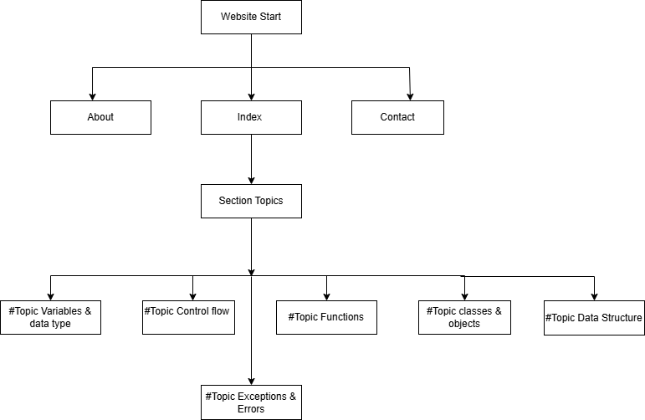

**Conclusion**

The "Learn Python Basics" website was developed with beginners in mind, those who may be curious about programming but unsure where to start. This platform offers a step-by-step path through Python’s core topics using simple explanations, useful visuals, and practical code examples that users can explore and download.

By focusing on ease of use, a clean design, and responsive layout, the site aims to make learning more comfortable for users on any device. The content is structured to help visitors learn at their own pace, with each section building on the last to form a complete foundation in Python programming. With the growing demand for programming skills, this site provides a valuable resource for anyone looking to begin their journey with Python straightforwardly and engagingly.

**REFERENCE**

* W3Schools – [https://www.w3schools.com](https://www.w3schools.com/)
* Mozilla Developer Network – [https://developer.mozilla.org](https://developer.mozilla.org/)
* Adobe Stock – [https://stock.adobe.com](https://stock.adobe.com/)
* Canva – [https://www.canva.com](https://www.canva.com/)
* Google Fonts – [https://fonts.google.com](https://fonts.google.com/)
* YouTube Creator Studio – [https://studio.youtube.com](https://studio.youtube.com/)

